Introduction to SQL & various DDL statements:

Problem :
Electricity_Reading Schema
Refer the ER diagram for Electricity_Reading shema and execute the following DDL Commands.
Note :
You have to complete all the queries of (Create/Alter/Drop) in the same attempt.
In case , if the session gets logged out ,the database in the backend will be cleaned.
So create the tables again when you work with the Alter and Drop queries.

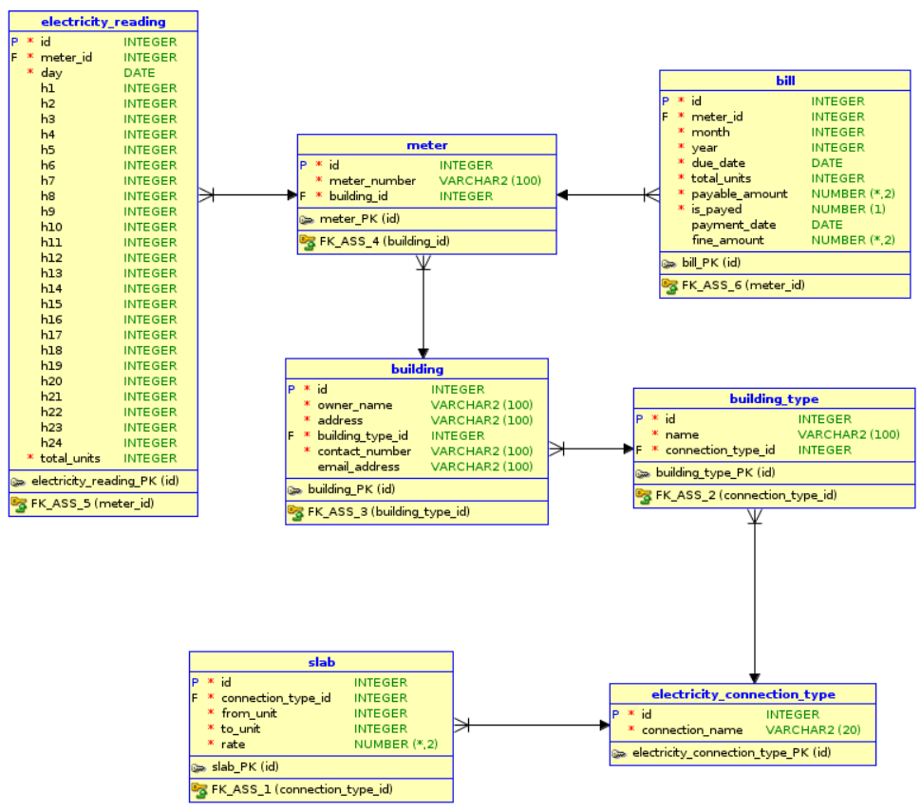

Q 1. Write a query to create 'building' table.
Ans:
CREATE TABLE building (
id INTEGER CONSTRAINT building_id_pk PRIMARY KEY,
owner_name VARCHAR2(100),
address VARCHAR2(100),
building_type_id INTEGER CONSTRAINT building_type_id_fk REFERENCES building (id),
contact_number VARCHAR2(100),
email_address VARCHAR2(100)
);

Q 2. Write a query to change the column name 'email_address' to 'email' in the building table.
Ans:
ALTER TABLE building RENAME COLUMN email_address TO email;

Q 3. Write a query to add new column "description" of type varchar(255) add not null constraint to building table.
Ans:
ALTER TABLE building ADD description VARCHAR(255) NOT NULL;

Q 4. Write a query to remove the column 'address' from the 'building' table.
Ans:
ALTER TABLE building DROP COLUMN address;

Q 5. Write a query to change the type of field 'owner_name' in the 'building' table to varchar(500);
Ans:
ALTER TABLE building MODIFY owner_name VARCHAR(500);

ACCESS :

Q 1. Write a query to create a table named 'station'.
Ans:
CREATE TABLE station (
id INTEGER CONSTRAINT station_id_pk PRIMARY KEY,
name VARCHAR2(100),
locality VARCHAR2(100),
is_interchange INTEGER
);

Q 2. Write a query to alter the column name 'locality' to 'station_locality' in the table 'station'.
Ans:
ALTER TABLE station RENAME COLUMN locality TO station_locality;

Access Additional :

Q 1. Write a query to add a new column named user_id of type NUMBER(20) to department table.
Ans:
ALTER TABLE department ADD user_id NUMBER(20);

Q 2. Write a query to add a constraint to the department table. user_id is a foreign key and it references id in the users table.
Ans:
ALTER TABLE department ADD FOREIGN KEY (user_id) REFERENCES users(id);

Q 3. Write a query to rename table department to departments.
Ans:
RENAME department To departments;

